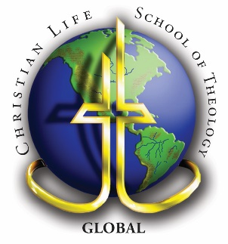
Christian Life Educators Network

6171 Gateway Dr., Columbus, GA 31909 • 706-323-0847
Christian Worldview Concentration (GoStrategic)

Course No. | Course Name | Units
 | GoStrategic: Strategic Life Training | 66
 | Core:
BT | Biblical Theology course | 3
CC | Christian Counseling course | 3
HT | Historical Theology course | 3
NT | New Testament course | 3
OT | Old Testament course | 3
PT | Practical Theology course | 3
 | Electives: | 42
 | Grand total for Bachelor Degree: | 126

GoStrategic SLT alumni receive 66 transferred units. Additional Core units as listed above are required (18 units of core) followed by the Elective units (42).

